Case 4-A86-Eur-Roman-Glass-Balsamarium Doublet-2nd-3rd cent. CE
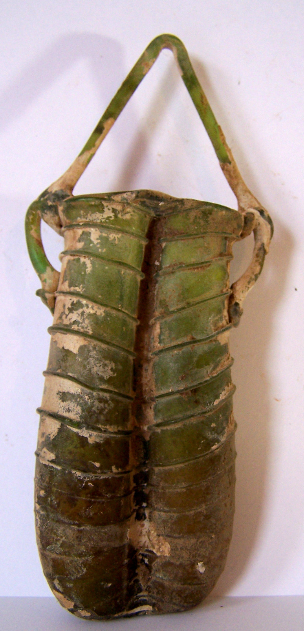 SHAPE \* MERGEFORMAT 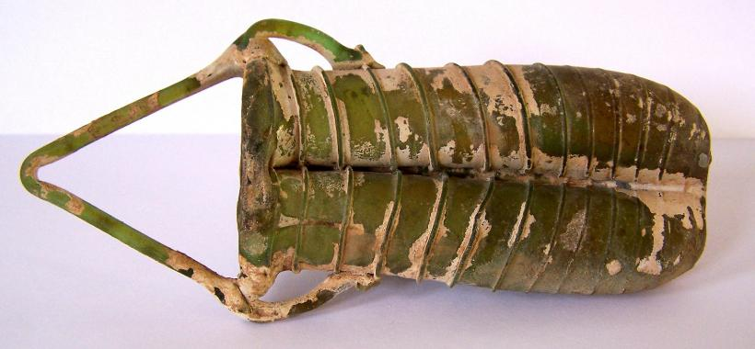

Case no.: 4
Accession Number: A86
Formal Label: Roman-Glass-Balsamarium Doublet-2nd-3rd cent. CE
Display Description:
This Balsamarium in aubergine shape consists of two separate tubular compartments with cylindrical necks and everted inward-folded lips. The body was formed by pinching one blown glass bubble at the center, and then folding it together. The body is wound with green spiral threads. An applied glass trail, grooved down the middle, forms the two thick looped handles on either side and extends to form a high arched basket handle. These vessels are presumed to have contained cosmetics and were most likely suspended at their side loops or handles (see Kunina and Gosudarstvennyi 1997: no. 413 and color plate no. 199 for a cosmetic flask with this type of handle).
LC Classification: NK.5107.3
Date or Time Horizon: Late 6th to early 7th century CE
Geographical Area: Rome
GPS coordinates: 31º46'5.95" N 35º12'49.36" E
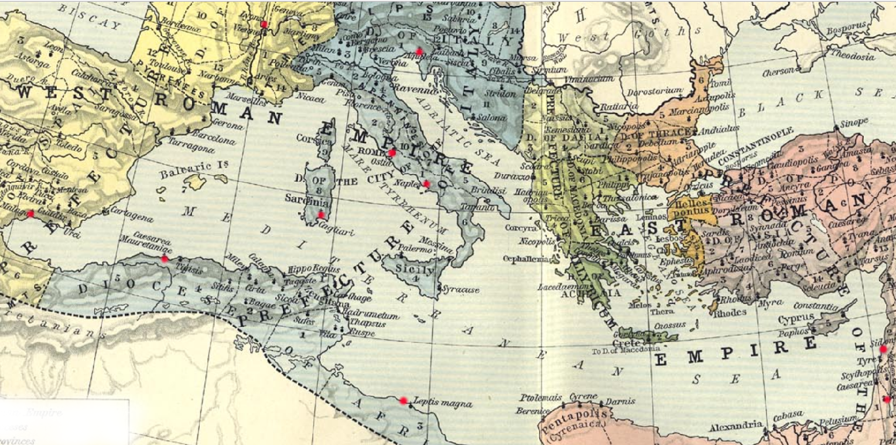

Map, East Roman Empire, 533-600. Red markers indicate diffusion of Sidonian glassblowers. From http://users.clas.ufl.edu/ufhatch/pages/03-Sci-Rev/SCI-REV-Home/Historical-Research/maps/shepherd-c-052.jpg
Cultural Affiliation: Roman
Medium: Blown glass
Dimensions:
Height: 15 cm, 5.9 in
Maximum Diameter: 7 cm, 2.75 in
Weight: 69 gm, 2 3/8 oz
Condition: original, good condition with patina and some encrustations and small crack
Provenance: Ex-Touma Dabbah Collection
Discussion:
On the eastern borders of the Roman Empire, according to Pliny ca 79 CE (Historia Naturalis 36), glassblowing (flatu figurare, "shaping by breath") was developed by the Sidonians of the Phoenician Pentapolis.
Glassblowing diffused because of factors political, legal and economic (see Fleming 1999). Politically, Augustus ended a century of civil strife in Italy and created a network of pacified provinces. Legally, Augustus ushered in an era of speedy and safe travel under Pax Romana that protected citizens of Rome from Syria to Spain. Economically, Italy experienced a boom that attracted and invigorated entrepreneurialism among artisans and merchants.
Consequently, many Sidonian glassblowers immigrated down the coast to Judea where they established ateliers at Jerusalem and possibly at Beth Shean (Scythopolis). But others ventured further afield to Italy and established a vicus vetrarius or “glassworkers’ quarter” in the vicinity of the Roman Porta Capena in the heart of the Empire (M. Bacchelli et al. 1995) and thereby introduced glassblowing to Romans (Stern 1995, 68-69). Other Italian ateliers were established in Ticino (Biaggio 1991), Naples (Campania; Stern 1976) and Aquileia (Calvi 1991; Scatozza Höricht; Calvi 1968).
Glass-blowing trade expanded to Switzerland (Avenches), to Gaul (Lugdunum, i.e., Lyon and Saintes; Nenna 1997; Hochuli-Gysel 1992; B. Velde and A. Hochuli-Gysel 1996), Corsica (Cagliari; Canivet, 1969: fig 15) to the south of the Iberian Peninsula (Price 1987), Libya (Tripoli; Aurigemma 1958, pl.15, fig. 19), and Roman-Berber North Africa (Caesarea Mauretaniae, i.e., Tipaza; Lance 1967).

References:
Aurigemma, Salvatore. 1958. Un Sepolcreto Punico-Pomano sotto il ‘Forte della Vite’ o ‘Forte nord-Ouest’ in Tripoli (Libia). Tripoli: Department of antiquities, Administration of Tripolitania.

Bacchelli, M. et al. 1995. “Nuove scoperte sulla prove- nienza dei panelli in opus sectile vitreo della collezione Gorga.” In Atti del 2 Convegno dell' Associazione Italiana per lo Studio e la Conservazione del Mosaico, Rome, 5-7 December 1994. Bordighera, pp. 447-66.

Biaggio Simona, S. 1991. I vetri romani provenienti dalle terre dell' attuale Cantone Ticino (Locarno 1991); HelvArch 22 (1991) 78-143.

Calvi, M. 1968. I vetri romani del Museo di Aquileia. Aquileia: Museo di Aquileia.

Calvi, M. 1991. “Arte vetraria Ticinese e arte vetraria Aquileiese: raffronti e analogie," Helvetia Archeolgia 22: 133-43.

Canivet, M.T.F. 1969. “I Vetri de Cornus conservati al Museo di Cagliari,” Journal of Glass Studies 11).

Fadić, Ivo. 1997. Trasparenze imperiali Vetri romani dalla Croazia [Dalmatia], exhibition catalogue. Rome: Palazzo Barberini; Milano: Skira.

Fleming, Stuart J. 1999. Roman glass: reflections on cultural change. Philadelphia: University of Pennsylvania Museum.

Giacchero, M. 1974. Edictum Diocletiani et Collegarum de pretiis rerum venalium. Genova : Istituto di storia antica e scienze ausiliarie.

Goitein S.D. 1967. A Mediterranean Society 1: Economic Foundations. Berkeley: University of California Press.

Hochuli-Gysel, A. 1992. “Römisches Glas aus dem Südwesten von Frankreich,” Annales du 12e Congrès de l'Association internationale pour l'histoire du verre, Vienne (Wien) 26 - 31 août 1991 12, 1991 (Amsterdam), pp. 79-88.

Isings, C. 1957. Roman Glass from Dated Finds. Archaeologica Traiectina 9, Groningen.

Kunina, Nina and Gosudarstvennyĭ Ėrmitazh. 1997. Ancient Glass in the Hermitage Collection. St. Petersburg : State Hermitage: ARS Publishers, 1997.

Lance, Sergel. 1967. Verrerie antique de tipasa: ouvrage publié avec le concours du conseil de la récherche scientifique en algerie, avec l' autorization du bureau des antiquites de l' algerie. Paris: Édition-Diffusion de Boccard.

Masseroli, Sara. 1998. Vetro e vetri: preziose iridescenze. Milano: Electa.

Morel, J. et al. 1992. “Un atelier de verrier du milieu du 1er siècle apr. J.-C. à Avenches,” Archäologie der Schweiz: Mitteilungsblatt der Schweizerischen Gesellschaft für Ur- und Frühgeschichte 15: 2-17.

Nenna, M.-D. et al. 1997. “L'atelier de verrier de Lyon, du 1er siècle après J.-C., et l'origine des verres ‘romains’,” Révue d'Archeometrie 21: 81-87.

Newby, M. and K. Painter, eds. 1991. Roman Glass: Two Centuries of Art and Invention. The Society of Antiquaries of London, Occasional Paper 13. London: The Society of Antiquaries of London.

Price, J. 1987. “Glass Vessel Production in Southern Iberia in the First and Second Centuries A.D.: A Survey of the Archeological Evidence,” Journal of the Glass Studies 29: 30-39.

Scatozza Höricht, L.A. 1991. "Syrian Elements among the Glass from Pompeii and Herculaneum [Campania]," in Newby, M. and K. Painter, eds. 1991. Roman Glass: Two Centuries of Art and Invention. The Society of Antiquaries of London, Occasional Paper 13. London: The Society of Antiquaries of London, pp. 76-85.

Stern, E.M. 1976. "A Small Glass Bottle on Three Pinched Feet [from Campania]," in Festoen Opgedragen aan A.N. Zadoks-Josephus fitta bij haar zeventigste verjaardag (Scripta Archaeologica Groningana 6, Groningen), pp. 527-38

Stern, E. M. and Birgit Schlick-Nolte. 1994. Early Glass of the Ancient World 1600 B.C. - A.D. 50: Ernesto Wolf Collection. Ostfildern: Verlag Gerd Hatje; New York: Distributed in the U.S.A. by Distributed Art Publishers.

Stern, E. M. 1995. The Toledo Museum of Art: Roman mold-blown glass: the first through sixth centuries. Rome: "L'Erma" di Bretschneider in association with the Toledo Museum of Art.

Stern, E. M. 2001. Roman, Byzantine, and early medieval glass, 10 BCE-700 CE: Ernesto Wolf collection. Ostfildern: Hatje Cantz; New York: Distributed in the U.S.A. by Distributed Art Publishers.

Tatton-Brown, V. 1991. "The Roman Empire". In H. Tait (ed.) Five Thousand Years of Glass. London: British Museum Press, pp. 62–97.

van Lith, Sophia Maria Elisabeth and K. Randsborg. 1985. "Roman Glass in the West: A Social Study," Berichten van de Rijksdienst voor het Oudheidkundig Bodemonderzoek 35 (1985) 413-32 and also as a separate reprint by Rijksdienst voor het Outheidkundig Bodemonderzoek.

Velde, B. and A. Hochuli-Gysel. 1996. "Correlations between Antimony, Manganese and Iron Content in Gallo-Roman Glass," Annales du 13e Congrès de l'Association Internationale pour l'Histoire du Verre, Pays-Bas, 13, 1995, pp. 185-91.

Weinberg, Gladys Davidson and the Corning Museum of Glass, eds. 1988. Excavations at Jalame: site of a glass factory in Late Roman Palestine. Columbia: University of Missouri Press.

AP:
A ROMAN GREEN GLASS BALSAMARIUM
5TH CENTURY A.D.
Images
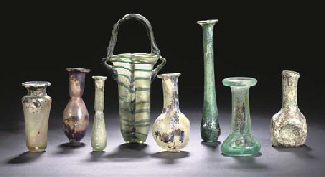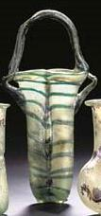
Enlarge
Price Realized (Set Currency)
£1,680
($2,938)
Sales totals are hammer price plus buyer’s premium and do not reflect costs, financing fees or application of buyer’s or seller’s credits.
Estimate
£800 - £1,200
($1,399 - $2,099)
Sale Information
Sale 7183
18 October 2005
London, King Street
Overview
Lot Notes
Lot Description
A ROMAN GREEN GLASS BALSAMARIUM
5TH CENTURY A.D.
The body wound with blue spiral threads, an applied blue trail forming a high arched handle, 5¼ in. (13.4 cm.) high; a Roman translucent aubergine glass flask, the ovoid body with cylindrical neck and everted inward-folded lip; five other glass vessels, some with iridescence, all 1st-3rd Century A.D., 4 7/8 in. (12.5 cm.) high max.; and a heavy green glass unguentarium, 2 7/8 in. (7.3 cm.) high (8)
Special Notice
No VAT will be charged on the hammer price, but VAT at 17.5% will be added to the buyer's premium, which is invoiced on a VAT inclusive basis.
Provenance
Item one: Baurat Schiller collection; Wilhelm Horn (1870-1959).
Items two-seven: sold Christie's London, 8 June 1988, lot 49 and acquired by the family of Wilhelm Horn.
View Lot Notes ›
www.christies.com/.../a-roman-green-glass-balsamarium... - United States

